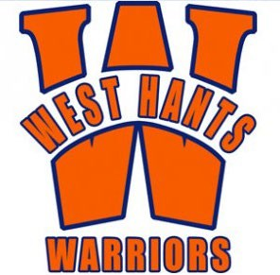**West Hants Minor Hockey Association**

October 14th, 2024

Dear Community Supporter,

On behalf of the West Hants Warriors **U11 A** team, we gratefully ask for your consideration of a donation to our team through a sponsorship banner. Our team consists of 17 9 and 10-year-olds who will proudly display your company on our team banner at all games throughout our season.

Hockey is a wonderful way to encourage physical activity among youth, providing an opportunity for players to grow and learn while developing skills they will carry throughout their lives. Our goal is to teach the skills required to play the game while providing a foundation in which children learn valuable skills such as fair play, respect, work ethic, and teamwork. These life skills will carry far beyond the hockey rink to help enrich the participants' lives and, ultimately, our community.

We are offering a tiered option to allow for what suits your business best:

|  |  |  |
| --- | --- | --- |
| Sponsorship Level | Description* | Amount |
| Gold | Large business/corporate logo placement on top half of banner. | $500 |
| Silver | Small business/corporate logo placement on bottom half of banner. | $250 |
| Bronze | Business/corporate name placement on bottom of banner. | $100 |

Contributions made by cash, cheque or electronic transfer are welcomed and to be received by **Monday, October 28th, 2024**. Electronic transfers may be sent to [**u11awesthants@gmail.com**](mailto:u11awesthants@gmail.com) using hockey as the password, cheques are payable to **WH Warriors U11A.** Please send a copy of your high-resolution logo to **u11awesthants@gmail.com**

With your generous support, you are ensuring maximized the opportunities for our team. We will be able to participate in upcoming hockey tournaments throughout Nova Scotia and beyond while having the ice time and equipment required to succeed. We seek to represent our team, West Hants Minor Hockey Association, our community, and your business with pride at all events in which we participate.

The players, coaches, and parents of the West Hants U11 A team thank you greatly for your support!

Sincerely,

Name

Team Manager

Email

LOGO INFORMATION FOR BANNER

*ALL sponsor logos are required to be in a vector format:*

*.ai*

*.eps*

*.cdr*

*TRUE .pdf*

*Copy & pasting a logo from the sponsor website will not work. Those are very low resolution & are only visible at 2”*

SAMPLE OF BANNER

